ImageToPH-ML: Machine Learning-Based pH Prediction from Images
Overview
Advisors: Dr. Aziz Fellah and Dr. Mohammed Meziani
Student Developer: Tanner Jackley
This project builds a machine learning pipeline that predicts pH values from images of pH indicators by extracting color features (HSV) and mapping them to continuous pH values using regression models. Traditional pH measurements rely too much on human estimates or require expensive equipment. This project aims to replace both processes with a ML pipeline that can estimate pH directly from an image.
Pipeline
Image -> Image preprocessing -> HSV color values -> ML model -> Predicted pH
Tech Stack
- Python
- scikit-learn
- OpenCV
- NumPy / Pandas
Goal
Build a real-time system that predicts pH from smartphone images for low-cost, portable chemical analysis.
Input: image of pH strip
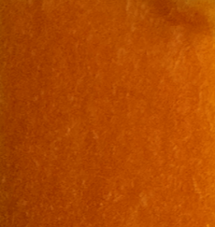
Output: Predicted pH = 2.6449
Current Status
✅ Synthetic dataset created
✅ ML pipeline implemented
✅ Baseline regression model trained
✅ Model evaluation working
✅ Image → HSV preprocessing started
✅ Real image dataset integration
✅ Advanced models (KNN, Decision Tree)
✅ Model comparison
✅ End-to-end prediction system
Implementation
1. Synthetic Data Generation
Synthetic data was used initially to prototype and validate the machine learning pipeline before integrating real-world image data.
Example row from dataset:
Hue | Saturation | Value | pH
0.212782432111785 | 0.7667570675423553 | 0.7222811080290041 | 5.243561663863074
This same structure would later be implemented using real images. This approach allowed for quicker development of the infrastructure for the project.
2. Data Pipeline & Model Training
Models: Linear Regression, K Neighbors Regressor, Decision Tree Regressor, Random Forest Regressor
- Put images into "data/meziani_images" (currently trained on 72 images)
- Extract HSV values from images
- Train model (split 80% train, 20% test)
- Output predicted pH
3. Model Evaluation
Evaluation metrics:
- Mean Squared Error (MSE)
- Coefficient of Determination (R²)
- Predicted vs actual comparison (based on test values)
This ensures the model is learning meaningful relationships.
4. Image Preprocessing
Image preprocessing pipeline
- Load image from filepath using cv2.imread
- Convert to HSV values using cv2.cvtColor
- Extract HSV values using cv2.split into Hue, Saturation, Value
- Normalize HSV values
Return example:
[0.0838, 0.7565, 0.9753]
72 Images to HSV Values:
Hue,Saturation,Value,pH
0.0067455498108886505,0.9947082540109865,0.5106943830163644,0.08
0.01391575869272696,0.978017898818384,0.5898749471672454,0.2
0.014439987903675053,0.9990419529635216,0.5085693536673929,0.3
0.031854621242258095,0.9822500179356853,0.6438397819020657,0.4
0.03518137026691496,0.973902096949891,0.7117728758169934,0.5
0.026093650184125725,0.9945266975969989,0.5419888576273081,0.6
0.039218262377191296,0.9865974306964165,0.6326152805949966,0.7
0.029792491019087413,0.9996263166681489,0.49562689084546047,0.8
0.05298937101697421,0.9732155380326019,0.6523489215401194,1.04
0.05774213943740743,0.9804626663646757,0.6582292542979788,1.23
0.06011579802142027,0.9894680359427961,0.6720486747603978,1.41
0.05878695538421288,0.9935576801886963,0.629736509479825,1.57
0.06688718679792423,0.9788778752661459,0.6871969381529666,1.82
0.07013940825207578,0.9873132630594237,0.6974707831850689,1.98
0.06800890303882333,0.9912983199428212,0.646775747868517,2.20
0.07068683933962347,0.9930682121728316,0.6614573708587135,2.41
0.06905063917451577,0.9937853416550017,0.6876348850508176,2.58
0.07717307710506642,0.995416968368375,0.6903948361953477,2.79
0.09522848352360132,0.995674168797954,0.6594858766695084,2.99
0.10861965192442699,0.9957488522977548,0.6813466282180454,3.22
0.07370996339291855,0.9941369598454977,0.6865365735897642,3.40
0.07357163070069742,0.9984041394335512,0.6540386710239651,3.47
0.06977719142617346,0.9965112529265707,0.6303685129188484,3.60
0.07283958167696165,0.9972388808743483,0.639023457220941,3.71
0.06766452820922095,0.9989901223647354,0.5812619784756008,3.77
0.0751318937298393,0.9981104986797587,0.6213095321760723,4.10
0.0818659217877095,0.9935962489343564,0.6244057971014493,4.18
0.09506446303242426,0.9992691622103387,0.5246277086957455,4.38
0.09521883986369223,0.9886289330547035,0.6539254516621463,4.50
0.11868834256680949,0.9633843422905062,0.6548727836608108,4.60
0.13762744693634155,0.8808768451200705,0.7230327636672647,4.80
0.1792996807661612,0.6829560574229692,0.5257484243697479,5.01
0.16552911593107805,0.8111311930537182,0.560327811834268,5.18
0.17822449726944897,0.5157563454215667,0.5044681217392001,5.43
0.14913114267902214,0.6966345888301149,0.647420814479638,6.17
0.19000026009618085,0.633390508862207,0.43411793533880105,6.40
0.20147872093105174,0.6256296516084366,0.3892001087950943,6.53
0.23959817538824255,0.8161180068357617,0.2502397846668399,6.80
0.26661181123958827,0.7090350103865836,0.3922869737042104,7.00
0.261234992539644,0.8123815105752447,0.25014132464580036,7.22
0.2749176911473844,0.5566444821747966,0.39053517400139937,7.53
0.2826984103273949,0.7799460871692705,0.27350552817680845,7.62
0.3198477517955746,0.5946115816197437,0.33656849951811957,7.76
0.3504738044880689,0.5219147623426968,0.35190106440359636,8.08
0.3502517567414632,0.6134561080417433,0.2967895135954935,8.22
0.37022816343998305,0.6170282605795941,0.33541532555051007,8.39
0.36352105484471675,0.7248867805186591,0.2612258064516129,8.51
0.3529860010932303,0.6780289727831431,0.22691038272688843,8.64
0.3679389931529357,0.6036946801282962,0.23118263260179173,8.83
0.3704660617727793,0.5478828679689511,0.2948632110755497,9.05
0.37894167101815224,0.5752002209334438,0.2630419076152299,9.25
0.3741146604275096,0.5935820624546114,0.2759489693313223,9.39
0.3739543948219597,0.8213645639251176,0.1857159756813736,9.59
0.3840475110108318,0.5658232518044476,0.3047043482072412,9.82
0.4702599108894805,0.697837160591306,0.27631020529016975,10.0
0.4884948389351382,0.7815131183027494,0.1600475849728093,10.21
0.4884948389351382,0.7815131183027494,0.1600475849728093,10.42
0.5178832340843514,0.9054670073157468,0.13056073711535895,10.64
0.5578932737910133,0.9735502935736672,0.10701067253463047,10.91
0.5532830158399312,0.8975135006416883,0.15590885621487457,11.02
0.5715891922279611,0.9297364690495666,0.11145912175960339,11.22
0.5754785340579435,0.9104207016139789,0.12643155039793696,11.38
0.5838212201153058,0.9224068542517634,0.13889529155657998,11.63
0.6045223470151617,0.9656175268070664,0.11866432062294949,11.79
0.6227019289317853,0.9582073849433301,0.09007246496244897,11.98
0.6298490105228932,0.949647266313933,0.10457224556489263,12.18
0.6162699181426557,0.8614514255398941,0.15066955098008727,12.39
0.6379513242292572,0.9628168119099492,0.10655954974582425,12.58
0.6356861565030811,0.9008495201359232,0.10767552922808468,12.84
0.6349234743020692,0.910379784097547,0.11127914767439542,13.07
0.6409741045454044,0.9606160743867439,0.10723127960861763,13.30
0.6393971103833558,0.9606317782285327,0.1092896281271129,13.50

5. Model Comparisons
Models from scikit-learn
Linear Regression
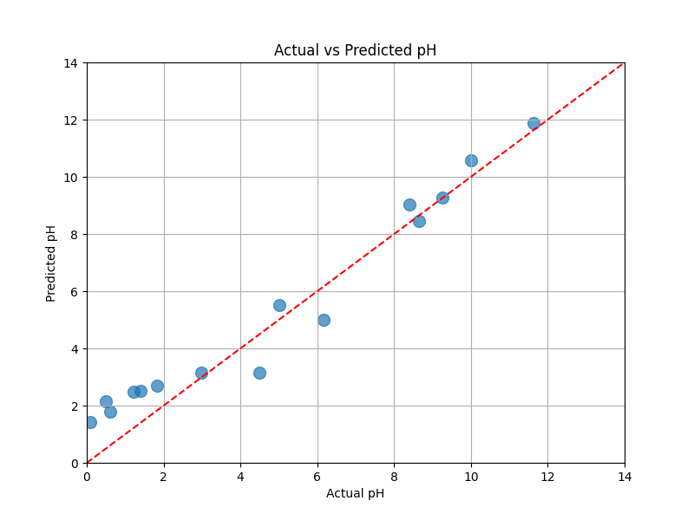
R² Score: 0.9365
MSE: 0.9219
Data Values:
Actual_pH,Predicted_pH
0.08,1.4155061859146278
0.5,2.1486359883002493
0.6,1.7926453460468297
1.23,2.4999817445978927
1.41,2.526791616369379
1.82,2.6934557000090966
2.99,3.1391641584230903
4.5,3.155860194551594
5.01,5.507103959731331
6.17,5.0080034640044735
8.39,9.042819311778274
8.64,8.46366339254084
9.25,9.272128507805833
10.0,10.580851227687567
11.63,11.876220357009235

K Neighbors Regressor
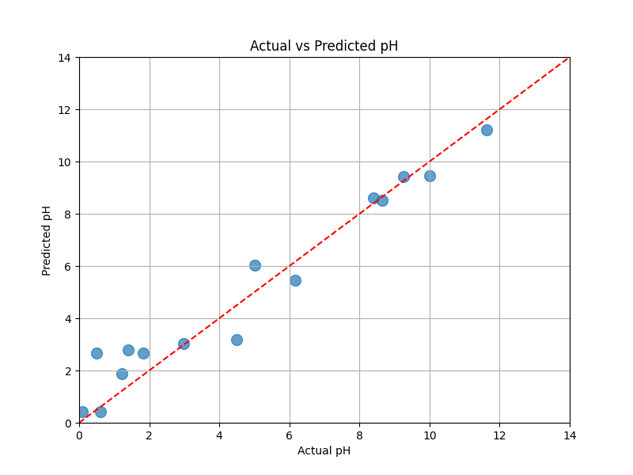
R² Score: 0.9464
MSE: 0.7782
Data Values:
Actual_pH,Predicted_pH
0.08,0.43333333333333335
0.5,2.6533333333333338
0.6,0.43333333333333335
1.23,1.8833333333333335
1.41,2.796666666666667
1.82,2.6533333333333338
2.99,3.0333333333333337
4.5,3.1966666666666668
5.01,6.036666666666666
6.17,5.460000000000001
8.39,8.6
8.64,8.520000000000001
9.25,9.42
10.0,9.44
11.63,11.206666666666669

Decision Tree Regressor
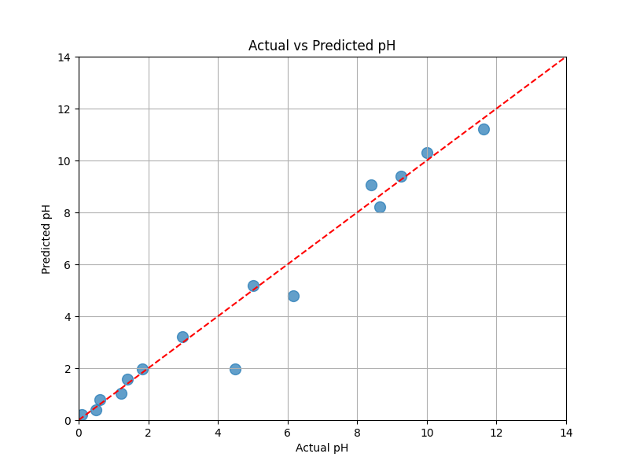
R² Score: 0.9571
MSE: 0.6240
Data Values:
Actual_pH,Predicted_pH
0.08,0.2
0.5,0.4
0.6,0.8
1.23,1.04
1.41,1.57
1.82,1.98
2.99,3.22
4.5,1.98
5.01,5.18
6.17,4.8
8.39,9.05
8.64,8.22
9.25,9.39
10.0,10.315000000000001
11.63,11.22

Random Forest Regressor
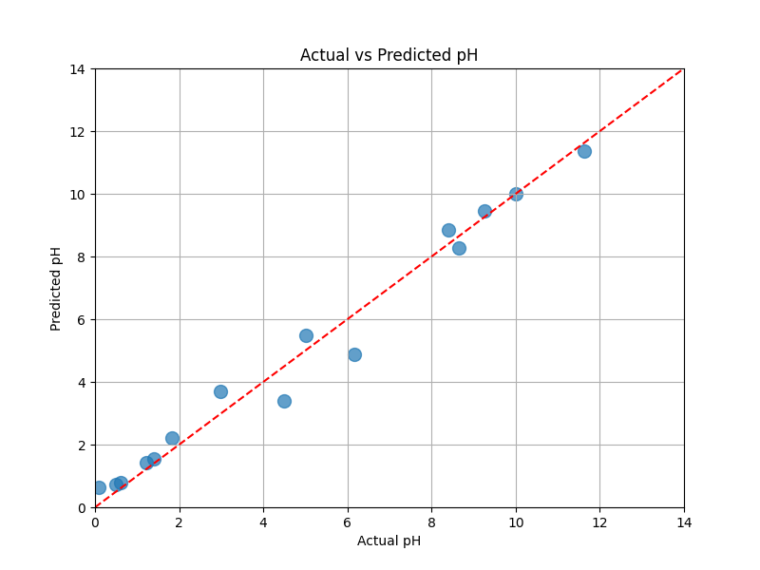
R² Score: 0.9786
MSE: 0.3116
Data Values:
Actual_pH,Predicted_pH
0.08,0.6418999999999997
0.5,0.7235000000000003
0.6,0.7986999999999991
1.23,1.4192999999999991
1.41,1.549699999999998
1.82,2.2229999999999985
2.99,3.6879000000000044
4.5,3.4066000000000027
5.01,5.4923
6.17,4.877500000000005
8.39,8.849900000000002
8.64,8.264800000000005
9.25,9.463499999999996
10.0,9.987795000000007
11.63,11.371000000000011

All Models
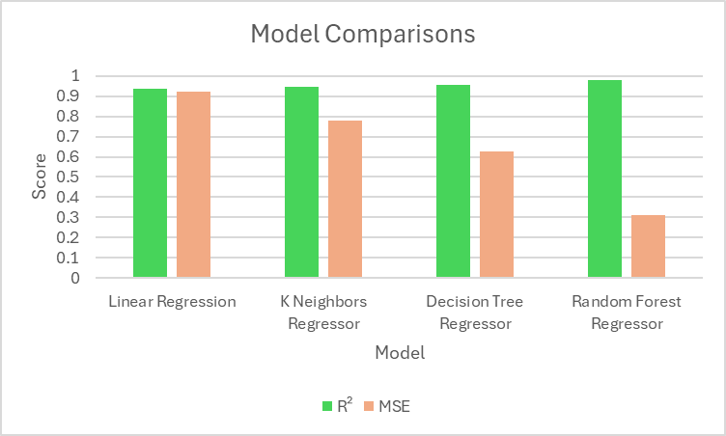
Model | R² | MSE
Linear Regression | 0.9365 | 0.9219
K Neighbors Regressor | 0.9464 | 0.7782
Decision Tree Regressor | 0.9571 | 0.6240
Random Forest Regressor | 0.9786 | 0.3116
Key Insights
HSV color space provides better separation of pH-related color changes than RGB
Tree-based models (Random Forest) outperform linear models due to nonlinear relationships between color and pH
Model accuracy improves significantly when using real image data vs synthetic data
How to run
git clone https://github.com/tanner-jackley/ImageToPH-ML.git
cd ImageToPH-ML/src
pip install -r requirements.txt
python main.py --image ../data/meziani_images/'2.58.png'
Citations
Elsenety, M.M., Mohamed, M.B.I., Sultan, M.E. et al. Facile and highly precise pH-value estimation using common pH paper based on machine learning techniques and supported mobile devices. Sci Rep 12, 22584 (2022). https://doi.org/10.1038/s41598-022-27054-5
Xiao, M., Liu, Z., Xu, N., Jiang, L., Yang, M., & Yi, C. (2020). A Smartphone-Based Sensing System for On-Site Quantitation of Multiple Heavy Metal Ions Using Fluorescent Carbon Nanodots-Based Microarrays. ACS Sensors, 5(3), 870–878. https://doi.org/10.1021/acssensors.0c00219

